Yamaha Nozzle
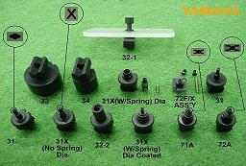
产品名称: Yamaha Nozzle 备注：原装件，台湾产仿制件
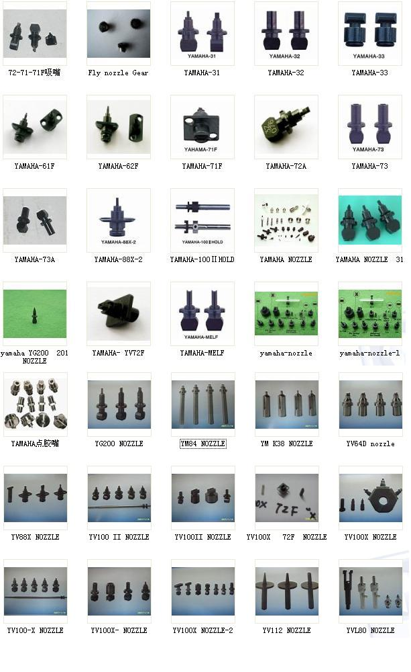
YVL88/YV100 PICK UP NOZZLE
1 | KM0-M711A-02X | YVL88/YV100 PICK UP NOZZLE-A(TYPE 31)
2 | KM0-M711A-02X | YVL88/YV100 PICK UP NOZZLE-A(TYPE 31)-'X'
3 | KM0-M711B-00X | YVL88/YV100 PICK UP NOZZLE-B(TYPE 32-1)
4 | KM0-M711C-00X | YVL88/YV100 PICK UP NOZZLE-C(TYPE 32-2)
5 | KM0-M711D-00X | YVL88/YV100 PICK UP NOZZLE-D(TYPE 33)
6 | KM0-M711E-00X | YVL88/YV100 PICK UP NOZZLE-E(TYPE 34)
7 | KM0-M711F-00X | YVL88/YV100 PICK UP NOZZLE-F(TYPE 35)MELF
8 | KM0-M711A-02X | YVL88/YV100 PICK UP NOZZLE-A(TYPE 31)-φ1.2/φ0.6
 |  | (ROUND TIP)SPRING LOADED
9 | KM0-M711A-02X | YVL88/YV100 PICK UP NOZZLE-A(TYPE 31)-'X'
 |  | SPRING LOADED
YV112 PICK UP NOZZLE
1 | KG2-M7191-100 | YV112 PICK UP NOZZLE TYPE 1 φ0.9/φ0.5
2 | KG2-M7191-200 | YV112 PICK UP NOZZLE TYPE 2 φ0.9/φ0.6
3 | KG2-M7191-300 | YV112 PICK UP NOZZLE TYPE 3 φ0.9/φ0.7
4 | KG2-M7191-400 | YV112 PICK UP NOZZLE TYPE 4 φ0.9/φ0.8
5 | KG2-M7191-500 | YV112 PICK UP NOZZLE TYPE 5 φ0.9/φ0.9
YMH PICK UP NOZZLE
1 | K38-M7113-H00 | YMH PICK UP NOZZLE a,φ1.1X0.7/φ0.4
2 | K38-M7113-B03 | YMH PICK UP NOZZLE b,φ1.8X1.1/φ0.8
3 | K38-M7113-C00 | YMH PICK UP NOZZLE g,φ3.0 /φ2.0
4 | K38-M7113-D01 | YMH PICK UP NOZZLE d,φ5.0 /φ3.5
5 | K38-M7113-E02 | YMH PICK UP NOZZLE e,φ1.1 /φ0.7(V)
YM 84 PICK UP NOZZLE
1 | KH-M7113-B00 | YM84 PICK UP NOZZLE ID:φ0.7(TYPE 2)
2 | KH-M7113-C00 | YM84 PICK UP NOZZLE ID:φ2.0(TYPE 8)
YM51V MII PICK UP NOZZLE
1 | KG9-M7113 -100 | YM51VM PICK UP NOZZLE S,COMP φ3.0/φ1.0
2 | KG9-M7113 -200 | YM51VM PICK UP NOZZLE M φ10.0/φ7.0
3 | KG9-M7113 -300 | YM51VM PICK UP NOZZLE L φ15.0/φ12.0
YANAHA YM51VM PICK UP NOZZLE
1 | K94-M7113-10X | YM51VM PICK UP NOZZLE L φ12.0/φ10.0
2 | K94-M7113-20X | YM51VM PICK UP NOZZLE L φ8.0/φ6.0
3 | K94-M7113-30X | YM51VM PICK UP NOZZLE L φ3.0/φ2.1
YAMAHA YV100X PICK UPNOZZLE
1 | KV8-M71U1-002 | YV100X PICK UPNOZZL ETIP TYPE 71F (2HOLE)
2 | KV8-M71U2-001 | YV100X PICK UPNOZZL ETIP TYPE 72F(0.92X1.75)'X'
3 |  | YV100X PICK UPNOZZL ETIP TYPE 7WF(φ1.2/φ0.6)'1608
4 |  | YV100X PICK UPNOZZL ETIP TYPE 7WF(φ1.6/φ1.1)'2125
5 | KV8-M71N1-A00 | YV100X FLOATING NOZZLE ASSY-TYPE 71F(2H0LE)
6 | KV8-M71N2-A00 | YV100X FLOATING NOZZLE ASSY-TYPE 72F('X')
7 | KV8-M71N3-A00 | YV100X FLOATING NOZZLE ASSY-TYPE 73F
8 | KV8-M7WK-A00 | YV100X PICK UP NOZZLE ASSY-TYPE 7WP(φ1.2/φ0.6)
9 |  | YV100X PICK UP NOZZLE ASSY-TYPE 7WP(φ1.6/φ1.1)
10 | KV8-M71U6-001 | YV100X NOZZLE HOUSING
11 | KV8-M7107-000 | YV100X SPRING
12 | KV8-M7105-001 | YV100X SCREW
13 | KV8-M7710-A0X | YAMAHA 71A ASSEMBLY NOZZLE (1.2X0.8)
14 | KV8-M7720-A0X | YAMAHA 72A ASSEMBLY NOZZLE (1.7X0.94)
15 | KV8-M7730-A0X | YAMAHA 73A ASSEMBLY NOZZLE
16 | KV8-M7740-A0X | YAMAHA 74A ASSEMBLY NOZZLE
17 | KV8-M7760-00X | YAMAHA 76A ASSEMBLY NOZZLE (MELF)
18 | KV8-M7WL-A00 | YAMAHA 7WA ASSEMBLY NOZZLE (φ1.2Xφ0.6)
19 |  | YAMAHA 7WA ASSEMBLY NOZZLE (φ1.6Xφ1.1)
YAMAHA YV88X
1 |  | YV88X PICK UP NOZZLE TIP -TYPE 61F (2HOLE)
2 |  | YV88X PICK UP NOZZLE TIP -TYPE 62F(0.92X1.75)'X'
3 | KGA-M71N1-A0X | YV88X PICK UP NOZZLE ASSY-TYPE 61F (2HOLE)
4 | KGA-M71N2-A0X | YV88X PICK UP NOZZLE ASSY -TYPE 62F (0.92X1.75)'X'
5 | KGA-M71N3-A1X | YV88X PICK UP NOZZLE ASSY -TYPE 63F
6 | KGA-M71N4-A0X | YV88X PICK UP NOZZLE ASSY -TYPE 64F
7 | KGA-M71N5-A0X | YV88X PICK UP NOZZLE ASSY -TYPE 65F
8 |  | YV88X NOZZLE HOUSING
9 |  | YV88X SPRING
10 | KV7-M7760-00X | YV88X TYPE 66A ASSEMBLY NOZZLE(MELF)
YV86/YV100D DISPENSING NOZZLE
1 | K37-M7113-20X | YV86/YV100D DISP NZ 1D/1S (FOR SOLDER PASTE)
2 | K37-M7113-10X | YV86/YV100D DISP NZ 1D/2S (FOR ADHESIVE)
3 | K37-M7113-00X | YV86/YV100D DISP NZ 2D/2S (FOR ADHESIVE)
4 | K37-M7113-40X | YV86/YV100D DISP NZ 2D/2S (FOR 1608 CHIPS)
YV64D/84D DISPENSING NOZZLE
1 | KG3-M7113-40X | YMH YV64D/84D DISP NZ 2D/2S φ0.7/φ0.4P=0.8
2 | KG4-M7113-10X | YMH YV64D/84D DISP NZ 2D/2S φ0.8/φ0.5P=10
3 | KG4-M7113-20X | YMH YV64D/84D DISP NZ 1D/2S φ0.6/φ0.3
4 | KG4-M7113-30X | YMH YV64D/84D DISP NZ 1D/2S φ0.8/φ0.5
5 | KG4-M7113-40X | YMH YV64D/84D DISP NZ 1D/2S IDφ1.5
6 | KG4-M7113-50X | YMH YV64D/84D DISP NZ 1D/2S IDEφ1.5
YMH DISPESING NOZZLE
1 | KV6-M7113-1XX | YMH KV6-7113 DISP NZ 2D/2S φ0.7/φ0.4P=0.9
2 | KV6-M7113-2XX | YMH KV6-7113 DISP NZ 2D/2S φ0.8/φ0.5P=1.3
3 | KV6-M7113-3XX | YMH KV6-7113 DISP NZ 2D/2S φ1.3/φ0.9P=1.8
4 | KV6-M7113-4XX | YMH KV6-7113 DISP NZ 1D/1S φ0.7/φ0.4
5 | KV6-M7113-5XX | YMH KV6-7113 DISP NZ 1D/1S φ0.8/φ0.5
6 | KV6-M7113-6XX | YMH KV6-7113 DISP NZ 1D/1S φ1.5/φ1.1
7 | KV6-M711A-XXX | YMH KV6-7113 DISP NZ 2D/2S φ0.7/φ0.4P=0.8
8 | KV6-M711B-XXX | YMH KV6-7113 DISP NZ 1D/1S φ1.5/φ1.1
9 | KV6-M711C-XXX | YMH KV6-7113 DISP NZ 1D/1S φ1.65/φ1.25

